Jerome School District
English Language Learner Program Plan

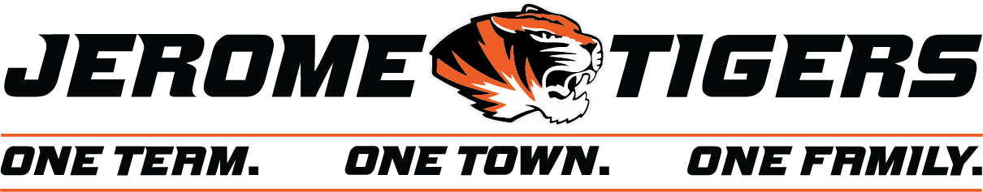

Table of Contents
Introduction 3
Mission Statement 3
Guiding Principles 3
Data 4
Identification Process 5
Parent Notification 7
Screening for Language Proficiency 7
Data Reporting 9
Language Instruction Educational Programs 10
English Learner Plans 10
Student Cumulative File 10
Annual Language Assessment for English Learners 11

Introduction
Jerome School District with the mission of Educating Today for Tomorrow’s World is focused on ALL learners reaching their greatest potential. As a district of just over 4000 students and about 23% being identified as English Learners, we are committed to tapping into the assets their experiences bring to the classroom.
It is our fundamental philosophy to provide equal educational opportunities to all students. The purpose of the Jerome School District English Language Learner Program Plan is to give an overview of procedural requirements and services to be provided to students with English language acquisition needs.
Mission Statement
It is the mission of Jerome School District English Learner Program to provide its students with the knowledge, skills, and confidence to be both communicatively and academically successful in English. This will be accomplished by providing a program that values the native language and culture of the EL student, provides students with the content knowledge and necessary background to meaningfully participate in the curricula, and equips students with the English language skills that are necessary tools for full participation in the K-12 education setting and future participation in the greater community.

Guiding Principles
We believe that:
- ELs are an asset to our classrooms therefore educators foster an assets-oriented mindset by knowing, valuing, and affirming their own, students’, and families’ cultures and languages, empowering students’ voices, and cultivating a joy of learning.
- ELs bring diverse cultural knowledge and experiences that contribute positively to the classroom and school environment
- Many ELs are halfway to bi literate
- Language acquisition is developmental and acquired through stages within the 4 domains of language: Listening, Speaking, Reading, and Writing
- ELs need to develop both BICS (social) and CALP (academic) language
- The academic success of ELs is a responsibility shared by all levels of educators, the family, and the community

2022-2023 English Learner Demographics
4168 Students enrolled

FLEP (Formerly Limited English Proficient) | 316 | 8%
X1-Students in their first year of exit status | 104 | 2%
X2-Second year of exit status | 80 | 2%
L1-first year in US education system | 148 | 3.5%
EL-students identified as an English Learner (not including L1) | 806 | 19%
EL-students identified as an EL or L1 | 954 | 23%
EL and Sped | 148 | 3.5%

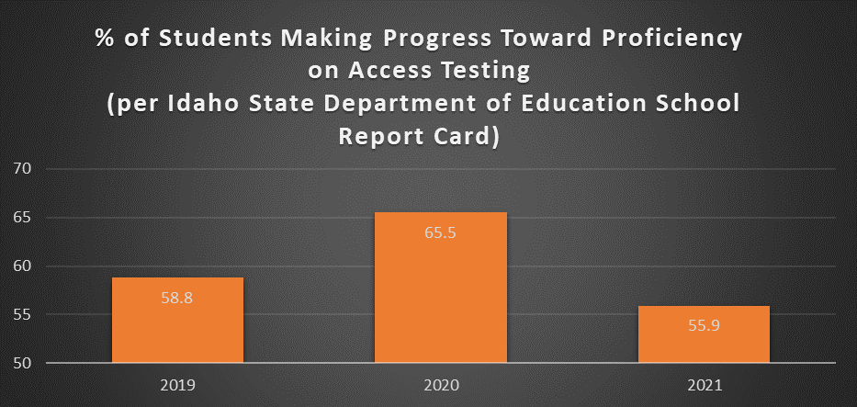

Jerome School District English Learner Identification Process

In accordance to the guidelines provided by the State Department of Education in the English Learner Program Manual (https://www.sde.idaho.gov/federal-programs/el/files/program/manual/English-Learner-Manual.pdf), Jerome School District will use the following procedure when determining the EL status of a student.

It is ultimately the responsibility of the English Learner certified staff member within each building to ensure we are doing our due diligence to identify and serve English Learners (EL) in our district within the timeline and parameters set forth by the State Department of Education English Learner Program Manual. Due to the large number of English Learners identified in Jerome School District, the Jerome School District Federal Program department will help streamline the process whenever possible.

Identification:
The first step in providing services to English Learners (ELs) is to identify students registering for school who may qualify for placement into a district/charter Language Instruction Educational Program. EL students in Idaho are classified according to the Federal government definition as described in the Elementary and Secondary Education Act (ESEA) Section 3201(5). An English Learner student is classified as one:
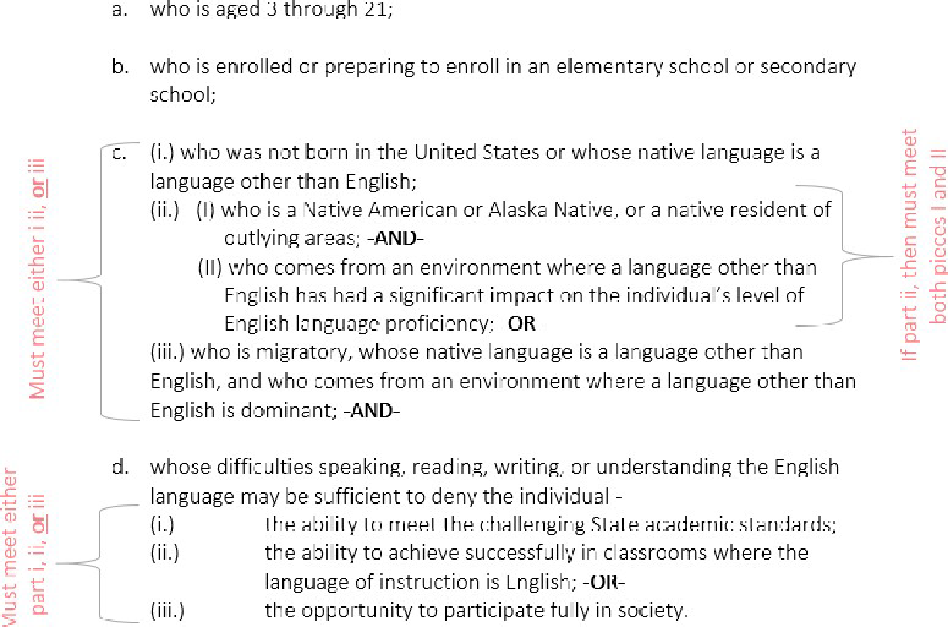

Step 1: Home Language Survey (HLS)
All students who enroll in Jerome School District for the first time must have an HLS completed, if the student is transferring from another Idaho district this HLS will be used as an interim HLS until the original Idaho HLS arrives in the cumulative folder. The original Idaho HLS should be placed in their cumulative file.
The HLS information is included in the new student report sent through each school’s enrollment clerk. Upon receiving new student reports it is the responsibility of the school EL certified staff to determine the need for further investigation.
- Students who have a language that is anything other than English marked warrant a follow up investigation. Use the Decision to Assess Matrix provided by the SDE (appendix) to determine the need for screening or phone call.
- Student should be looked up in Powerschool to determine if the student has previously been in Jerome School District. Transfer info should show this, if yes, Special Program Enrollment should be looked at to determine any prior EL history.
- If student is new to Jerome but coming from another Idaho district, again Transfer Info will show this information, the student should be looked up in the State Department of Education English Learner Management System (ELMS) to determine previous EL enrollment in sending district. If student has been in the Idaho school system for 2+ years and never been identified as EL, we will not proceed with further identification. If student is less than 2 years in Idaho, check cumulative folder information for evidence of old HLS with documentation of not screening.
- For students who are coming from another state, school EL certified staff need to use due diligence to determine student’s status through the following avenues:
  - If student is from a WIDA state, call previous school or check cumulative folder and send all evidence of EL status including test results, Screener date, EL entry date, date of first enrollment in US school, EL Exit date to Federal Program secretary for enrollment into our student information system as well as ELMS.
  - If student is not coming from a WIDA state,
    - Call home to determine language use in the home and participation in previous school’s EL program
    - Call sending school to determine participation in previous school, if student was previously identified, ask for evidence that shows screener scores and date, as well as EL entry date, date of first enrollment into US school, and any other testing information which could include exit status.
    - Look through student cumulative folder for any EL identification information including screener scores, screener date, EL entry date, EL exit date, etc.
    - If student is coming from a non WIDA state and left their state as an EL, student must be screened to determine if student meets Idaho criteria.
    - If student is coming from a non WIDA state and was exited from the EL program in that state we will honor that exit status, must have evidence of exit letter to enter into ELMS.
- Send WIDA screener information along with EL entry date and date of first enrollment in US school from sending state to Federal Program secretary for enrollment into our student information system as well as ELMS.
- Copies of all testing documentation should be placed in the student’s cumulative folder inside the brown EL folder.
- All documentation of EL status will be input into the PowerSchool and ELMS via the Federal Program secretary to ensure consistent documentation.

Reminder, there is as 30 day window from enrollment to identify a student as EL

Jerome School District English Learner Parent Notification

Upon enrollment into JSD EL programming a letter must be sent to the parents of the student notifying them of the program enrollment and the results of the most recent WIDA assessment. The district approved JSDParentNoficationForm shall be used by all schools. At the beginning of the school year the JSD Federal Program department will send the letters and previous year’s WIDA Access scores or current WIDA Screener scores for all currently enrolled EL students through the district office. Once mass notification has occurred in mid-September, students identified during the school year will be the responsibility of the school EL certified staff member. (See Appendix)

Screening for English Language Proficiency
Jerome School District follows the strict guidelines set forth by the Idaho State Department of Education English Learner Program Department (https://www.sde.idaho.gov/federal-programs/el/files/program/manual/English-Learner-Manual.pdf) in conjunction with the English Language Proficiency Department (https://www.sde.idaho.gov/assessment/elpa/ ). As Idaho is part of the WIDA Consortium, all screening materials used are aligned to the WIDA testing platform. Provisional English learners in kindergarten and first semester of first grade are administered the one on one WIDA Kindergarten Screener while provisional English learners who are in second semester grade 1 through 12 are given either the WIDA Paper Pencil Screener or the WIDA Online Screener..
All test administrators must recertify each year to proctor the screener assessments as well as Access 2.0.
WIDA Screener for Kindergarten and WIDA Screener
Students in kindergarten (listening and speaking domains) and first semester grade one ( all four domains) are screened using the WIDA Screener for Kindergarten. Students in second-semester grade one through grade 12 are screened using the WIDA Screener (Online or Paper). First and second-semester are defined as:
- First semester-from the school year start date through December 31st
- Second semester-from January 1st through the end of the school year
For all other grade levels (second-semester grade 1 through grade 12) provisional ELs are administered the WIDA Screener (Online or Paper). Due to the organization of grade level clusters through WIDA, students entering the first semester of a new grade-level cluster should be assigned the lower-grade level cluster.
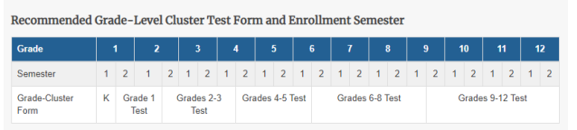
WIDA Screener Screen-Out Criteria
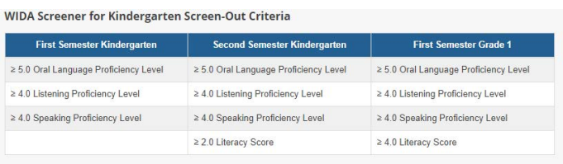
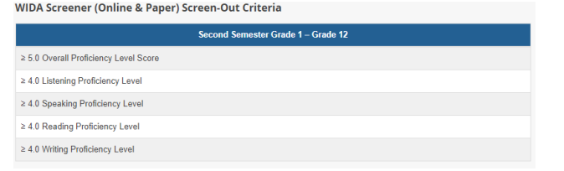
Provisional ELs who are screened and reach a level that shows they have enough English language to be successful in school are identified at Screened Out and coded as SO in the student information system. These students are not identified as English Learners and are not entered into the EL program.

Data Reporting
Once a student has been identified as EL either through enrollment transfer and previously identified or through the screening process and qualified, the identification will be logged in several places via the Federal Program secretary. Student EL status will be logged in our student information system, PowerSchool, under Special Programs as well as an alert added. The student will then be tagged in Milepost and added to the EL Program. Student information will also be entered into the Idaho State Department of Education English Learner Management System (ELMS).
The following codes will be used as per SDE EL Program Guidance:
EL Status Codes
EL Code | EL Status | Has an EL Entry Date | Has an EL Exit Date | Takes the Access?
L1 | An English learner who has been identified in the past year. This status rolls over to LE after one year.  ELs are exempt from ISAT ELA testing for one year from the first date of enrollment to a US school. | Yes | No | Yes
LE | A continuing English Learner. This status remains until he/she meets exit criteria. | Yes | No | Yes
EW | A current English Learner whose parents have waived EL services. This status is prompted by the annual upload of a signed waiver form from the parents | Yes | No | Yes
X1 | A student who has met Idaho’s exit criteria on the annual Access assessment or the Alternate Access in the previous school year. These students are currently in their first year of monitoring status | Yes | Yes | No
X2 | A student who has met Idaho’s exit criteria on the annual Access assessment two school years ago. these students are in their second year of monitoring status | Yes | Yes | No
X3 and X4 | A student who has met Idaho’s exit criteria on the Annual Access assessment. These students are no longer monitored but are counted within the EL subgroup for Accountability purposes. | Yes | Yes | No
FL | A student who met Idaho’s exit criteria more than five years ago and is now a Former EL student. | Yes | Yes | No
SO | A student who has met Idaho screen out criteria on a WIDA screener and is NOT qualified as an EL student. | No | No | No

Language Instruction Educational Program (LIEP)
All districts must select one or more methods of instruction that are effective in teaching English Learners. Under Title VI and the EEDA school districts must provide a core language that is effective-educational sound and proven successful.
LIEP Models Used in Jerome School District

50/50 two way immersion
English/Spanish
K-7 currently but will have secondary path for high school
50% of cohort is native English/50% of cohort is native Spanish

Dual Language Immersion

K-12
Each building has a language specialist
Specific curriculum and methodology for acquiring language
Can be push or pull out
Push in-teacher goes into general education classroom for support
Pull out-student goes to EL teacher room for langauge support

English as a Second Language (ESL)

Sheltered Instruction Oberservational Protocol (SIOP) used in the general education classroon providing lanuage instruction taht uses content as a medium for building language skills

Content Classes with Integrated ESL Support

English Learner Plans
Idaho statute (IDAPA 08.02.03-111.04) requires that an individualized ELP is written for any student who requires any accommodations or designated supports on a statewide or district-wide assessment based upon the language proficiency. Assessment accommodations/supports must also be used during regular classroom instruction and testing. ELPs are written by a team that has evaluated the language needs of the individual student.
Student Cumulative File and EL Record
The following items must be placed in a student’s cumulative file within the brown English Learner folder:
- Original Idaho Home Language Survey
- A copy of the original EL placement testing (WIDA Screener for Idaho, other forms for other states)
- Current and previous EL Assessment Results (WIDA Access)
- Parent Notification of testing and placement in EL program
- Parent Waiver form (if one is submitted)
- EL Exit Form once student reaches EL exit status
- LEPX1 and LEPX2 monitoring forms for first two years of EL exit status
- English Learner Plan if one is created

Annual Language Assessment for English Learners
All students who are currently identified as an English Learner in Jerome School District will participate in the annual WIDA Access test. The Federal Program Director ensures each year that the ELMS pre-id upload file is ready in November. And then correlates PowerSchool and WIDA DRC in early January to ensure any new students have been added to DRC for testing and that accommodations are accurately marked according to the most recent IEP.
The English Learner department and the Special Education department will work closely to ensure that a student’s IEP reflects the accommodations needed on the Access to successfully participate with their peers. Monthly a list of students who are dually identified IEP and EL is sent to each building team as a reminder to work together when IEPs come due. In early January prior to Access testing the Federal Program Director works with the special education department to ensure the shared google sheet of accommodations is up to date according to current IEPs and ensures those are accurate in DRC.
Testing security measures will include ensuring all test administrators have received necessary WIDA training for the assessments they will administer. The building EL teacher will facilitate this training and the Federal Program Director will use WIDA certification portal to ensure proctors are certified before testing begins. Federal Program Director will collect SDE Assessment Confidentiality Agreement forms from all test administrators and keep them on file for two years. Materials arrive at the district office and are immediately inventoried. Materials are kept in a secure location until distributed to the buildings. Federal Program Director will deliver materials to each building. The building EL teacher is responsible to inventory all materials and place them in a secure locked location. Materials are to be kept in a locked secure location at all times. EL teachers are responsible for printing and keeping test tickets in a secure location and shredding tickets when done. EL teachers are responsible for ensuring test administrators follow test administrator scripts, addressing electronic devices including watches and phones during testing, and students end the test before closing out. If there is a situation that ends in a test incident (wrong person taking the test, someone taking pictures of test items, cheating, test theft, etc.) the EL teacher needs to let the Federal Program Director know immediately so she/he can submit a test incident log. If there is an interruption that results in a student not finishing the test domain in one day, without an accommodation, it needs to be reported to the Federal Program Director within 24 hours so that he/she can submit a test incident log. Once testing is complete at the building the EL teacher is responsible to inventory all materials before Federal Program Director is scheduled to come back and pick up testing materials. The Federal Program Director will inventory one final time before sending materials back to DRC.
During the Access testing window building EL teachers and testing coordinators ensure all EL students are tested. Weekly and eventually daily cumulative testing reports are ran to ensure all students are tested. Annually the Federal Program Director addresses any appeals within the appeal window providing evidence whenever possible.

